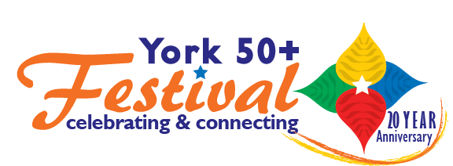

**Form B: Business sponsorship and advertisements York 50+ Festival**

**Celebrate life, community & creativity at York’s only festival dedicated to the over 50s!**

The 20th York 50+ Festival will run from **Saturday 20 September to Wednesday 1 October 2025.**

This year **York Older People’s Assembly (YOPA) and Age UK York (AUKY)** are collaborating to host the York 50+ Festival - a unique, 10-day event featuring an exciting mix of talks, performances and social activities including a parade for the **International Day of Older People** in central York on Saturday 27th September.

Our new [Sponsorship Pack downloadable from the YOPA website](https://www.yorkassembly.org.uk/wp-content/uploads/2025/05/Sponsorship-Pack-4pp-Single-Pages-final.pdf) outlines a range of sponsorship offers from being a *Friend of the Festival*, a *Community Supporter* to an *Event Partner* or even our *Headline Sponsor*. Now is the time for local businesses to consider how they can take advantage of this opportunity. All contributions and events will be published in the Festival brochure available from early September – 3,500 minimum copy distribution plus media publicity and website presence for 12 months.

1. If you would like to place an advertisement in the programme, please complete the form below. (*Friend of the Festival* - Full A5 page ad £200 or ½ page ad A5 £100)

2. If you would like to hold an event (or events) please complete a copy of **Form A Festival event/s application**, attached or downloadable from the YOPA website.

**Completed forms must be returned by email or to the YOPA address no later than by 21 July**.

3. To discuss specific sponsorship options in the pack with the Festival Team please email us at[[*yorkfiftyplus@gmail.com*](mailto:yorkfiftyplus@gmail.com)](mailto:%20yorkfiftyplus@gmail.com) or call 07850 111299 as soon as possible.

## __

Please complete and return by 21 July programme deadline.

Contact Name……………………………………... Phone………………………………………………...

Email………………………........... Organising business………….…………………………………….……….

Address……………………………………………………….……………….…………………………….……….

Please select advert size: ½ A5 page (13x8.5cm, landscape) £100

Full A5 page (13x17cm, portrait) £200

**Artwork in high quality jpeg format only please (no PDFs).**

a) Please email the completed form with artwork attached to [*yorkfiftyplus@gmail.com*](mailto:yorkfiftyplus@gmail.com). If you are a sponsor, please also provide a high res. jpeg of your logo.

b) Please pay by BACS to YOPA bank account: **77997668 sort code: 30-99-50.** And add ref. 50+ and your admin contact surname.

If you prefer to pay by cheque please make payable to YOPA and send to **YOPA, St Sampson’s Centre, Church Street, York YO1 8BE** together with a paper copy of this form for reference.

Editorial copy to fit A5, to be provided at **arial 12 pt**

**York Older People’s Assembly**

**St Sampsons Centre, Church St, York, YO1 8BE**

**Registered Charity 1101018**

[yorkolderpeoplesassembly@outlook.com](mailto:yorkolderpeoplesassembly@outlook.com)

[www.yorkassembly.org.uk](http://www.yorkassembly.org.uk/)