PR 1 final

Celebrate life, connections and creativity at York’s only festival dedicated to the over 50s!

York Older People’s Assembly and Age UK York announce plans
for York 50+ Festival
Saturday 20 September to Wednesday 1 October 2025

York Older People’s Assembly (YOPA) and Age UK York are collaborating to host the York 50+ Festival - a unique, 10-day event featuring an exciting mix of talks, performances and social activities. The only festival in York dedicated to those over 50, it’s a fun social event where 50+ individuals, along with their friends and families, can explore available offers and enjoy free or low-cost activities.
This year’s festival theme is Celebrating and Connecting. With 77,030 residents aged over 50 in York, our goal is to highlight the evolving and diverse experience of growing older. Since YOPA’s inception in 2001, views around ageing have changed significantly - people are living longer, spanning multiple generations, and redefining what it means to be 50+. Twenty years ago, no one was playing walking football or pickleball. Expectations of later life are shifting dramatically.
This festival is an invitation to actively participate in York's vibrant community and offers a space to challenge ageism and celebrate the energy, creativity, and contributions of older people. It is a collective endeavour to bring people together to try something new, celebrate older residents and increase social connection and intergenerational community.
Celebrating its 20th year, the festival embraces the UN designated International Day of Older People (IDOP) and runs from Saturday 20 September to Wednesday 1 October, with a Day of Celebration and Central Parade in York on Saturday 27 September.
Simon Holmes, CEO, Age UK York added “We are striving to make York a great place to grow old in. Our exciting plans seek to dispel ageist stereotypes, highlight the diverse experiences of older people, enhance wellbeing and enjoyment, and foster intergenerational understanding and links.”
Professor Dianne Willcocks, Vice Chair, YOPA says “Sadly, the experience of ageism persists in our society - with nearly half of people over 50 in England reporting age discrimination. Happily, here in York, this unique event is designed by those over 50, for those over 50, to showcase events that inspire, entertain, and connect. The York 50+ Festival has something for everyone and we would love you to be part of it.”
Open to anyone looking to learn something new, meet like-minded people, or simply have fun, this festival is all about embracing new experiences and enjoying life to the fullest - whether you’re 55, 75 or 95!
The activities will include an exciting mix of talks, performances and social activities, alongside a ten-day exhibition trail in popular venues across York city centre. Activities are spread out across the wider geography of York, delivered by local groups, businesses and organisations and are accessible to all.
As part of the celebration, eco-friendly leaves will be created by groups young and old to symbolise growth, connection and wisdom. These will be paraded through the city on Saturday 27 September culminating in a civic welcome, bringing the community together in a vibrant display of unity and recognition.
Next steps
- Save the dates
  - Saturday 20 September – Festival opening event
  - Saturday 27 September - York 50+ day of celebration with parade from 13.30
  - Wednesday 1 October 17.00-19.00 - International Day of Older People and recognition to those who have supported
- Get involved either as a volunteer, sponsor or putting on activities
  - See our sponsorship pack on the webpage
  - If you are interested in promoting an event, complete the form on the webpage
- Find out more on the YOPA website www.yorkassembly.org.uk/50-festival-2025/
- Email address
  - yorkfiftyplus@gmail.com
- See social posts and through partner organisations.




Ends

About YOPA
York Older People’s Assembly (YOPA) is an independent local charity which has advocated for, celebrated and supported older people across York and North Yorkshire since 2001. We are an organisation of older people, for older people and we work to achieve full citizenship for diverse older people across and within the wider community.
We aim to:
- Represent the views of older people in York to decision makers locally and nationally.
- Inform older people about services that are available.
- Identify where needs are not being met.
- Work with the local authority and others to make York an age-friendly city
As part of the 50+ Festival, this is the third year in which YOPA has successfully led a city-wide collaborative for International Day of Older People.

About Age UK York
Age UK York is an independent local charity which has been working in the local community to help older people for over 50 years. We have 100 dedicated staff and over 400 volunteers helping us to deliver services and activities for older people in York. Age UK York provides free, confidential and impartial information and advice on a range of issues relating to older people and those who care for and support them.

We offer a wide range of services to older people in York to enable them to live better lives. This includes information and advice, benefits and money advice, befriending services, carer respite service, Day Clubs and Home From Hospital support. All our work is aimed at improving the lives of older people in York. Age UK York encourages older people to speak out about local and national issues. We are here to make more of life in York.

About the International Day of Older People
Each year on October 1, people across the world mark United Nations International Day of Older People to raise awareness of opportunities and challenges faced by ageing populations, and to mobilise the wider community to address challenges faced by older people. The theme for 2025, is the role older people play in creating resilient, sustainable societies.

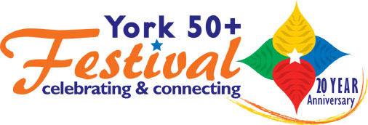
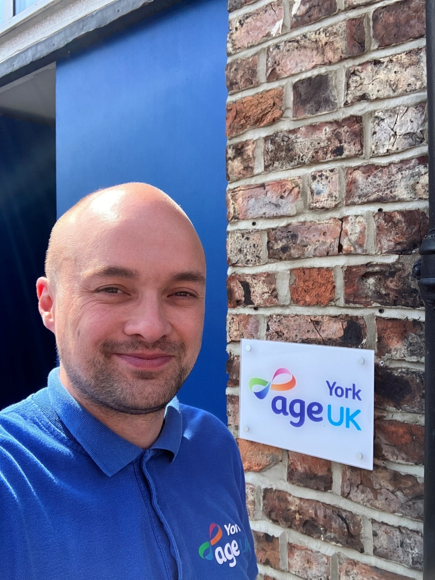
Simon Holmes, CEO, Age UK York

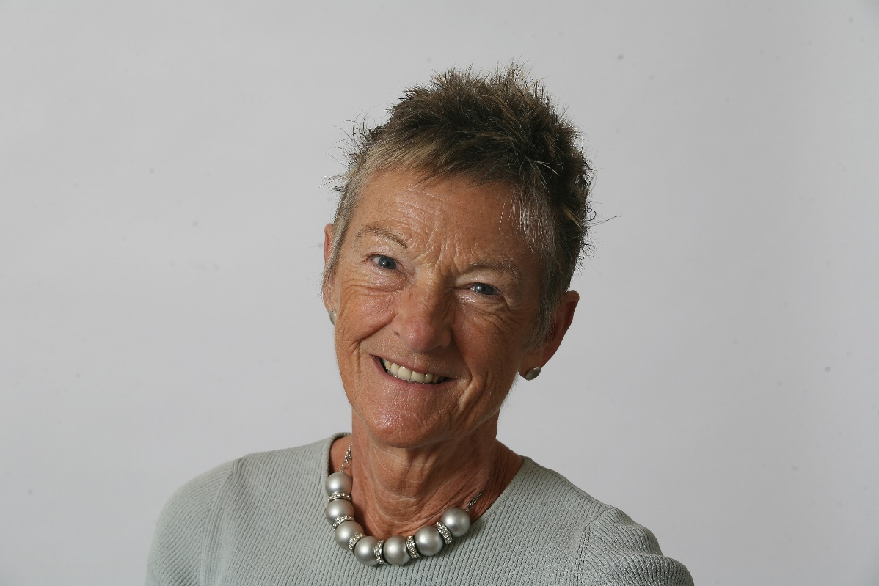
Professor Dianne Willcocks, Vice Chair, YOPA

